|  |  |  |  |  |  |  |  |  |  |  |  |  |  |  |  |  |  |  |  |  |
| --- | --- | --- | --- | --- | --- | --- | --- | --- | --- | --- | --- | --- | --- | --- | --- | --- | --- | --- | --- | --- |
| **North South University**  Department of Electrical & Computer Engineering  **LAB REPORT-** *08*  *\*\*Erase everything that is in red & italics*  Course Code: EEE111L  Course Title: Analog Electronics  Section: *06*  Lab Number: *07*  Experiment Name:  Experiment Date: *20th May 2023*  Date of Submission: *27th May 2023*  Submitted by Group Number: *04*  Group members:   |  |  |  |  | | --- | --- | --- | --- | | Name | ID | Obtained Mark Simulation [5] | Obtained Mark Lab Report [15] | | 1.Muhammad Raiyan Alam | 1831100642 |  |  | | 2.Sadia Tahasin | 1921397042 |  |  | | 3.Mosroor Mofiz Arman | 1921079642 |  |  | | 4.Md Shahidul Islam | 1822169642 |  |  |   Course Instructor: *Mohammad Shorif Uddin (MHUd)*  Submitted To: Md. Anisur Rahman Asif |

1. **Experiment Name**: Study of Switching Characteristics
2. **Objectives:** To investigate the characteristics and study of JFET and MOSFET behavior when used as a switch.
3. **Apparatus:**

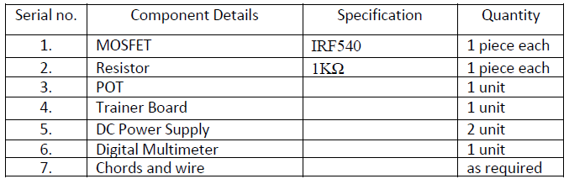

1. **Theory:**

There are two main differences between BJTs and FETs.

1. FETs are charge controlled devices while BJTs are current or voltage-controlled devices.
2. The input impedance of the FETs is very high while that of BJT is relatively low.

As for the FET transistors, there are two main types:

* the junction field-effect transistor (JFET) and
* the metal oxide semiconductor field effect transistor (MOSFET).

The power dissipation of a JFET is high in comparison to MOSFETs.

The combination of n - type and p - type MOSFETs allow for the realization of the Complementary Metal Oxide Semiconductor (CMOS) technology, which is nowadays the most important technology in electronics. All microprocessors and memory products are based on CMOS technology. The very low power dissipation of CMOS circuits allows for the integration of millions of transistors on a single chip.

Today, in this experiment, we will investigate its characteristics and study MOSFET behavior when used as a switch.

MOSET like all other IGFETs has three terminals, which are called Gate (G), Source (S), and Drain (D).

There are four types of MOSFETs: enhancement n-type MOSFET, enhancement p-type MOSFET, depletion n-type MOSFET, and depletion p-type MOSFET.

The type depends whether the channel between the drain and source is an induced channel or the channel is physically implemented and whether the current owing in the channel is an electron current or a hole current.

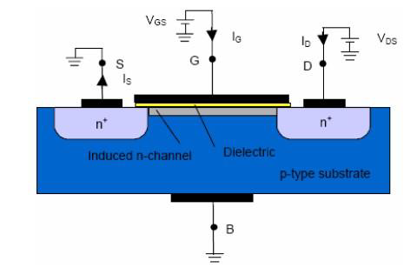

1. **Circuit Diagram:**

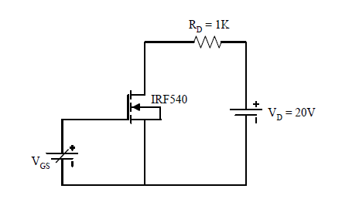

1. **Experimental Procedure:**
2. Initially, we set VGS to zero and record the VDS, VL and ID.
3. Slowly, we increase the gate voltage VGS gradually and record the readings.
4. We take reading until ID = 20mA (or the saturation current of the MOSFET) and we note the condition of VDS and ID.
5. Next, repeat the experiment for VDD = 15 Volts.
6. **Results:** In the lab, we did theoretical analysis base on the mathematical equation and predicted what might be the answer. In simulation, we analysed the circutal behaviour. Practical results are obtained through real-world implementation of the biasing circuits and direct measurements. Based on all the activity that we have done, we can conclude the Study of Switching Characteristics.

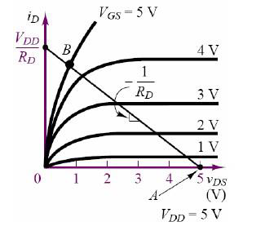

1. **Questions and Answers (Q/A):** No Question were in the Lab Manual

**Add:**

1. **Discussion**: Attach
2. **Experimental Data Table:** Attach
3. **Simulation:** Attach

**Discussion:** Muhammad Raiyan Alam 1831100642

There are two main differences between BJTs and FETs are FETs are charge controlled devices while BJTs are current or voltage-controlled devices and the input impedance of the FETs is very high while that of BJT is relatively low. As for the FET transistors, there are two main types JFET and MOSFET. The power dissipation of a JFET is high in comparison to MOSFETs.

The combination of n - type and p - type MOSFETs allow for the realization of the CMOS technology, which is nowadays the most important technology in electronics. All microprocessors and memory products are based on CMOS technology. The very low power dissipation of CMOS circuits allows for the integration of millions of transistors on a single chip. In today’s experiment, we will investigate its characteristics and study MOSFET behavior when used as a switch.

MOSET like all other IGFETs has three terminals, which are called Gate (G), Source (S), and Drain (D).

There are four types of MOSFETs: enhancement n-type MOSFET, enhancement p-type MOSFET, depletion n-type MOSFET, and depletion p-type MOSFET.

The type depends whether the channel between the drain and source is an induced channel or the channel is physically implemented and whether the current owing in the channel is an electron current or a hole current.



**Simulation:**

